National University of Computer and Emerging Sciences



AL-2002: Artificial Intelligence
Lab Manual 14

Department of Compyter Science
FAST-NU, Lahore, Pakistan

Table of Contents
Objectives 3
1 Introduction to CNNs 3
1.1 Input Layer 4
1.2 Convolution Layer 4
1.3 Activation Function (ReLU) 5
1.4 Pooling Layer 5
1.5 Flatten Layer 6
1.6 Fully Connected (Dense) Layer 6
2 Implementing CNN using Python 6

Objectives
After performing this lab, students shall be able to:
- Understand the working of Convolutional Neural Networks (CNNs).
- Identify and explain different CNN layers (Convolution, Pooling, Fully Connected).
- Implement a CNN model using Python and deep learning libraries.
- Train and evaluate CNN models on image datasets.
- Interpret results using accuracy and loss curves.

Introduction to CNNs
A Convolutional Neural Network (CNN) is a type of deep learning model primarily used for processing structured grid data such as images. CNNs automatically learn spatial hierarchies of features using convolution operations.
Unlike traditional neural networks, CNNs require less preprocessing and are highly effective in image classification, object detection, and pattern recognition tasks.
Images contain spatial information (height, width, channels). CNNs
- Preserve spatial relationships
- Require fewer parameters than fully connected networks
- Automatically extract features (edges, textures, shapes)
A typical CNN consists of multiple layers stacked together:
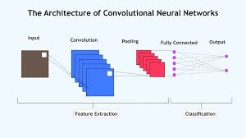
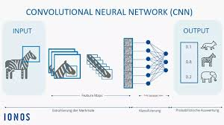

Input Layer

The input layer defines the shape of the data entering the network. For image data, this includes height, width, and number of channels.

For example, grayscale images have 1 channel, while RGB images have 3 channels.

tf.keras.Input(shape=(28, 28, 1))
shape=(28,28,1) means 28 = height, 28 = width, 1 = grayscale channel

Convolution Layer
The convolution layer applies filters (kernels) to extract features from input images.

Mathematically:
𝐹𝑒𝑎𝑡𝑢𝑟𝑒 𝑀𝑎𝑝 = 𝐼𝑛𝑝𝑢𝑡 ∗ 𝐾𝑒𝑟𝑛𝑒𝑙

Where: Input = Image matrix, Kernel = Filter matrix
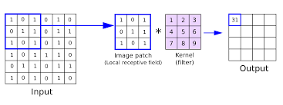
tf.keras.layers.Conv2D(32, (3,3), activation='relu')
- 32 (filters): number of feature detectors
- (3,3): size of filter (kernel)
- activation='relu': introduces non-linearity

Activation Function (ReLU)
ReLU (Rectified Linear Unit) introduces non-linearity:
𝑓(𝑥) = 𝑚𝑎𝑥 (0,𝑥)
It helps the network learn complex patterns.
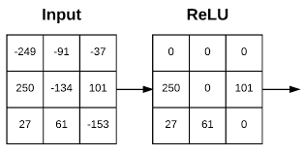

Pooling Layer

Pooling reduces spatial dimensions and computation. Types:
- Max Pooling (most common)
- Average Pooling

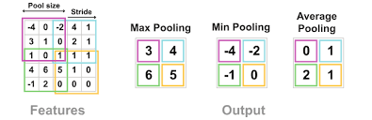
tf.keras.layers.MaxPooling2D((2,2))

pool_size: Size of pooling window (2×2 reduces dimensions by half)

Flatten Layer

Before passing data into dense layers, the 2D feature maps must be converted into a 1D vector.

tf.keras.layers.Flatten()

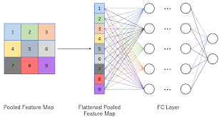

Fully Connected (Dense) Layer
Dense layers learn complex relationships between extracted features and output labels.
The final layer usually uses softmax activation for multi-class classification.
tf.keras.layers.Dense(64, activation='relu')
tf.keras.layers.Dense(10, activation='softmax')

Implementing CNN using Python

We will use a sample dataset such as handwritten digits (MNIST).
First, the dataset (MNIST) is loaded, which contains grayscale images of handwritten digits. The pixel values are normalized by dividing by 255 so that all values lie between 0 and 1, improving training efficiency. The images are reshaped into a 4D format (samples, height, width, channels) because CNNs expect channel information.
import tensorflow as tf
from tensorflow.keras import datasets

# Load dataset
(x_train, y_train), (x_test, y_test) = datasets.mnist.load_data()

# Normalize data
x_train = x_train / 255.0
x_test = x_test / 255.0

# Reshape for CNN
x_train = x_train.reshape(-1, 28, 28, 1)
x_test = x_test.reshape(-1, 28, 28, 1)

Next, a Sequential model is created, which allows stacking layers one after another. The first convolution layer applies 32 filters of size 3×3 to extract basic features from the image. This is followed by a max pooling layer that reduces the spatial dimensions, making computation efficient.

A second convolution layer with 64 filters is added to capture more complex patterns, followed again by pooling. The output is then flattened into a one-dimensional vector so it can be fed into dense layers.

A dense layer with 64 neurons learns high-level patterns, and the final dense layer with 10 neurons (one for each digit class) uses softmax activation to output probabilities.

import tensorflow as tf

model = tf.keras.Sequential([

# Input Layer
tf.keras.Input(shape=(28, 28, 1)),

# Convolution + Pooling
tf.keras.layers.Conv2D(32, (3,3), activation='relu'),
tf.keras.layers.MaxPooling2D((2,2)),

# Second Convolution + Pooling
tf.keras.layers.Conv2D(64, (3,3), activation='relu'),
tf.keras.layers.MaxPooling2D((2,2)),

# Flatten
tf.keras.layers.Flatten(),

# Fully Connected Layers
tf.keras.layers.Dense(64, activation='relu'),
tf.keras.layers.Dense(10, activation='softmax') # Output Layer
])
model.summary()
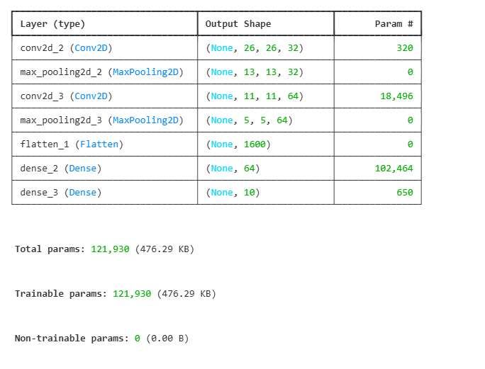
The model is compiled using the Adam optimizer and a suitable loss function for classification. It is then trained for multiple epochs, during which it learns patterns in the data.

model.compile(optimizer='adam',
loss='sparse_categorical_crossentropy',# for multiclass
metrics=['accuracy'])

history = model.fit(x_train, y_train, epochs=5, validation_split=0.2)

Finally, the model is evaluated on test data to measure its accuracy (you can find other evaluation metrics as well in the same manner we covered under ANN (Tensorflow-Lab 10).

test_loss, test_acc = model.evaluate(x_test, y_test)
print("Test Accuracy:", test_acc)

Visualization of Training

import matplotlib.pyplot as plt

# Accuracy Plot
plt.plot(history.history['accuracy'], label='Train Accuracy')
plt.plot(history.history['val_accuracy'], label='Validation Accuracy')
plt.legend()
plt.title("Accuracy Curve")
plt.show()

# Loss Plot
plt.plot(history.history['loss'], label='Train Loss')
plt.plot(history.history['val_loss'], label='Validation Loss')
plt.legend()
plt.title("Loss Curve")
plt.show()
Question 1 — Handwritten Digit Classification using CNN
Build a Convolutional Neural Network (CNN) using TensorFlow to classify handwritten digits from the MNIST dataset.
Tasks:
- Load the MNIST dataset using TensorFlow.
- Normalize pixel values between 0 and 1.
- Reshape images into CNN format (28,28,1).
- Build a CNN model containing:
  - Input layer
  - One Conv2D layer with 32 filters
  - One MaxPooling2D layer
  - Flatten layer
  - Dense hidden layer
  - Output layer with softmax activation
- Compile the model using:
  - Adam optimizer
  - sparse_categorical_crossentropy loss
- Train the model for 5 epochs.
- Evaluate model accuracy on test data.
- Plot:
  - Training vs Validation Accuracy
  - Training vs Validation Loss
----------------------
Question 2 — CNN with Multiple Convolution Layers
Design a deep CNN model for image classification using the Fashion MNIST dataset.
Tasks:
- Load the Fashion MNIST dataset.
- Normalize and reshape the images.
- Build a CNN model with:
  - Two Conv2D layers
  - Two MaxPooling2D layers
  - Flatten layer
  - Dense layer with ReLU activation
  - Output layer with softmax activation
- Display the model summary.
- Train the model for 10 epochs.
- Evaluate test accuracy.
- Plot:
  - Accuracy curve
  - Loss curve
----------------------
Question 3 — CNN Performance Analysis using Learning Curves
Implement a CNN model and analyze its training performance using learning curves.
Tasks:
- Load the MNIST dataset.
- Preprocess the dataset:
  - Normalize images
  - Reshape images for CNN
- Build a CNN model using:
  - Conv2D
  - MaxPooling2D
  - Flatten
  - Dense layers
- Train the model with validation split = 0.2.
- Extract:
  - Training accuracy
  - Validation accuracy
  - Training loss
  - Validation loss
- Plot:
  - Accuracy curves
  - Loss curves
- Analyze whether the model shows:
  - Good fitting
  - Overfitting
  - Underfitting
----------------------
Question 4 — Image Classification using CNN with Dropout
Develop a CNN model with Dropout layers to reduce overfitting.
Tasks:
- Load the MNIST dataset.
- Normalize and reshape the images.
- Build a CNN model containing:
  - Conv2D layers
  - MaxPooling2D layers
  - Dropout layers
  - Flatten layer
  - Dense layers
- Use:
  - Dropout(0.5)
  - ReLU activation
  - Softmax output layer
- Compile and train the model for 8 epochs.
- Evaluate the model on test data.
- Plot:
  - Training accuracy vs Validation accuracy
  - Training loss vs Validation loss
- Compare model performance before and after using Dropout.

